**Panasonic Lumix G X Vario 12-35mm f/2.8 II ASPH. POWER O.I.S. Lens**

**$897.99**

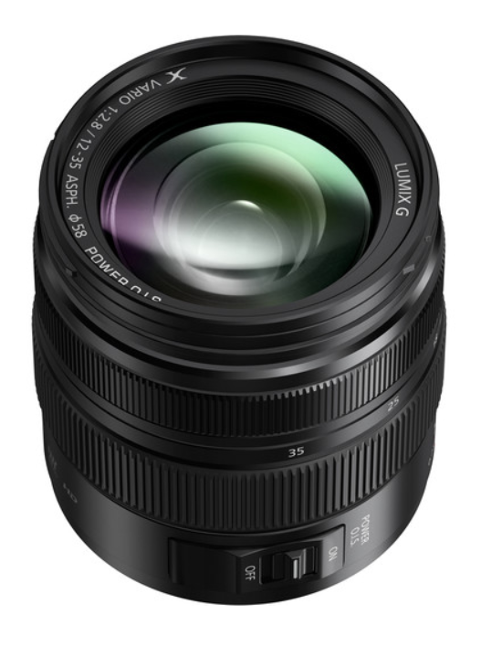

* Micro Four Thirds System
* 24-70mm (35mm Equivalent)
* Aperture Range: f/2.8 to f/22
* Four Aspherical Elements
* One UED Element and One UHR Element
* Nano Surface Coating
* POWER Optical Image Stabilizer
* Splash, Dust, and Freezeproof Design
* Rounded 7-Blade Diaphragm

*A versatile zoom covering wide-angle to portrait-length perspectives, the****Lumix G X Vario 12-35mm f/2.8 II ASPH. POWER O.I.S. Lens****from****Panasonic****is designed for Micro Four Thirds cameras, where it provides a convenient 24-70mm equivalent focal length range. A constant f/2.8 maximum aperture affords consistent performance throughout the zoom range, and benefits working in difficult lighting conditions as well as enables greater control over depth of field. The sophisticated optical design employs a series of aspherical, low dispersion, and high refractive index glass elements to control a variety of aberrations and distortions for sharp, clean image quality and a Nano Surface Coating has also been applied to reduce ghosting and flare. A POWER Optical Image Stabilizer minimizes the appearance of camera shake to suit handheld shooting, and this O.I.S. system is also compatible with Dual I.S. for enhanced stabilization performance. Additionally, the lens also features a durable all-metal housing that is dust, splash, and freezeproof to enable its use in harsh climates.*

* Standard zoom for Micro Four Thirds mirrorless cameras, this lens provides a 24-70mm equivalent focal length range.
* Bright constant f/2.8 maximum aperture maintains consistent performance throughout the zoom range.
* Four aspherical elements, one ultra extra-low dispersion element, and one ultra high refractive index element all contribute to minimizing chromatic and spherical aberrations and various aberrations in order to produce a high degree of clarity, sharpness, and color accuracy.
* Nano Surface Coating has been applied to individual elements to reduce flare and ghosting for improved contrast and color neutrality.
* POWER Optical Image Stabilizer minimizes the appearance of camera shake for sharper handheld shooting, and also supports the Dual I.S. function for increased stabilization performance.
* Splash, dust, and freezeproof design benefits working in inclement weather conditions.
* Rounded seven-blade diaphragm contributes to a smooth and pleasing bokeh quality.